**Assignment - 4**

|  |  |
| --- | --- |
| Assignment Date | 9 November 2022 |
| Student Name | OVIYA S |
| Student Roll Number | 210219106027 |
| Team Id | PNT2022TMID36774 |

**Question-1:**

Write a code and connections in wokwi for the ultrasonic sensor. Whenever the distance is less than 100cms send an “Alert” to IBM cloud and display in the device recent events.

**Wokwi Simulation Link**:

https://wokwi.com/projects/346382633340502612

**Code:**

|  |
| --- |
| #include <WiFi.h>  #include <PubSubClient.h> void callback(char* subscribetopic, byte* payload, unsigned int payloadLength);  //-------credentials of IBM Accounts------  #define ORG "ytluse"//IBM ORGANITION ID  #define DEVICE_TYPE "2702"//Device type mentioned in ibm watson IOT Platform  #define DEVICE_ID "12345"//Device ID mentioned in ibm watson IOT Platform  #define TOKEN "O+n)Eh+lNX0y3?rG!8" //Token String data3; char server[] = ORG  ".messaging.internetofthings.ibmcloud.com"; char publishTopic[] = "iot-2/evt/Data/fmt/json"; char subscribetopic[] = "iot-2/cmd/test/fmt/String"; char authMethod[] = "use-token-auth"; char token[] = TOKEN; char clientId[] = "d:" ORG ":" DEVICE_TYPE ":" DEVICE_ID;  WiFiClient wifiClient;  PubSubClient client(server, 1883, callback  ,wifiClient); const int trigPin = 5; const int echoPin = 18; #define SOUND_SPEED 0.034 long duration; float distance; void setup() { **Serial**.begin(115200); pinMode(trigPin, OUTPUT); pinMode(echoPin, INPUT);    wificonnect();  mqttconnect();  }  void loop()  { digitalWrite(trigPin,  LOW);  delayMicroseconds(2); |

|  |
| --- |
| digitalWrite(trigPin, HIGH); delayMicroseconds(10); digitalWrite(trigPin, LOW); duration = pulseIn(echoPin, HIGH); distance = duration * SOUND_SPEED/2;  **Serial**.print("Distance (cm): ");  **Serial**.println(distance); if(distance<100) { **Serial**.println("ALERT!!"); delay(1000); PublishData(distance); delay(1000); if (!client.loop()) {  mqttconnect();  } }  delay(1000);  } void PublishData(float dist)  { mqttconnect();  String payload = "{\"Distance\":"; payload += dist; payload += ",\"ALERT!!\":""\"Distance less than 100cms\""; payload += "}";  **Serial**.print("Sending payload: ");  **Serial**.println(payload);    if (client.publish(publishTopic, (char*) payload.c_str())) { **Serial**.println("Publish ok");  } else {  **Serial**.println("Publish failed");  }  } void mqttconnect()  { if  (!client.connected()) {  **Serial**.print("Reconnecting client to "); **Serial**.println(server);  while (!!!client.connect(clientId, authMethod, token)) { **Serial**.print("."); delay(500);  }  initManagedDevice();  **Serial**.println();  } } void  wificonnect()  {  **Serial**.println();  **Serial**.print("Connecting to ");  WiFi.begin("Wokwi-GUEST", "", 6); while  (WiFi.status() != WL_CONNECTED) { |

delay(500);

**Serial**.print(".");

}

**Serial**.println("");

**Serial**.println("WiFi connected");

**Serial**.println("IP address: ");

**Serial**.println(WiFi.localIP());

} void initManagedDevice()

{

if (client.subscribe(subscribetopic)) { **Serial**.println((subscribetopic)); **Serial**.println("subscribe to cmd OK");

} else {

**Serial**.println("subscribe to cmd FAILED");

} } void callback(char* subscribetopic, byte* payload, unsigned int payloadLength) {

**Serial**.print("callback invoked for topic: "); **Serial**.println(subscribetopic); for

(int i = 0; i < payloadLength; i++) {

//Serial.print((char)payload[i]); data3

+= (char)payload[i];

}

**Serial**.println("data: "+ data3); data3=""; }

**Diagram.json:**

|  |
| --- |
| {  "version": 1,  "author": "IRFANA FATHIMA A 19IT007",  "editor": "wokwi", "parts": [  { "type": "wokwi-esp32-devkit-v1", "id": "esp", "top": 6, "left": -66, "attrs": {}  },  { "type": "wokwi-hc-sr04", "id": "ultrasonic1", "top": 32.56, "left": 81.02, "attrs": {} }  ],  "connections": [  [ "esp:TX0", "$serialMonitor:RX", "", [] ],  [ "esp:RX0", "$serialMonitor:TX", "", [] ],  [ "esp:VIN", "ultrasonic1:VCC", "red", [ "h-31.67", "v-176.8", "h152", "v163.33" ]  ],  [ "esp:D18", "ultrasonic1:ECHO", "green", [ "h11.37", "v64.67", "h121.33" ] ],  [ "esp:D5", "ultrasonic1:TRIG", "green", [ "h16.7", "v45.07", "h4" ] ],  [ "esp:GND.1", "ultrasonic1:GND", "black", [ "h8.7", "v14.7", "h138.67" ] ] ]  } |

**Circuit Diagram:**

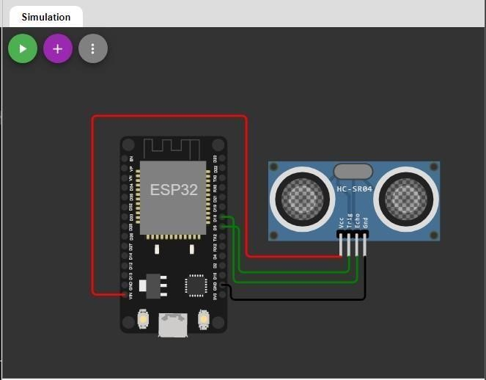

**Output:**

Wokwi output:

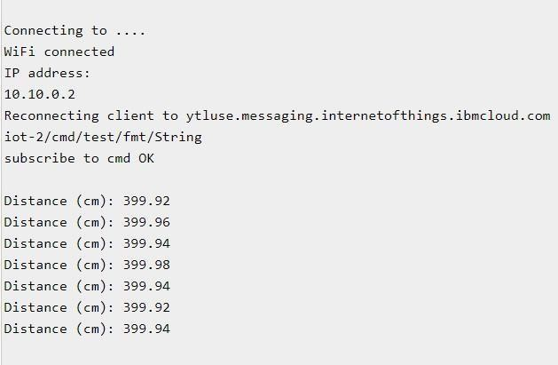

**IBM cloud output:**

